The vast majority of the time, your API will probably be working perfectly well, but not providing data to your application quickly enough to be perceived as instant by your users. When a page in your application appears empty for even a fraction of a second, it can make your app seem like it is unresponsive, or not working correctly, or just sluggish. This is easy to forget when you’re developing your app on a beefy workstation - particularly if your dev environment includes your API, database, and app. You may be seeing imperceptible loading times of <200ms, but that won’t be representative of your app’s typical consumer. They could be in the middle of nowhere, traveling, underground, or throttled for some suspect reason (looking at you, AT&T!).

Perceived loading time is particularly sensitive in the case of people loading your app on mobile devices - whether through a browser or from a native app downloaded from their respective app store. These are people who can experience download speeds that vary wildly from moment to moment - and honestly, this is something that can be really easy to lose sight of.

You - you - the developer/designer/maker of this thing, are building your app in an environment you have some control over. Your home office or your couch are likely connected to a predictably performant broadband network. If you work in a traditional office or a coworking space, high-speed broadband is generally a safe bet, too. Hell, even if you're throwing back $7 lattes while designing and building your app at your local specialty coffee shop, I'd bet your connection is pretty damn good. In any of these cases, if your connection degrades or goes down, you've very likely got a plan B that your users may not have.

What I want you to do here is close your eyes and imagine yourself using your app from somewhere else, with a less ideal connection. Maybe you're on a train riding from Brussels to Paris, with a spotty wifi connection that comes and goes as you fly through the countryside. Maybe you're in a quiet cafe in Vietnam, sipping an iced coffee in the sweltering heat, connected to a network that makes everything just a bit of a struggle. What if you’re on a mobile phone in the middle of Pune India, on a crowded 3G Network, or in Midtown NYC where the signal is inexplicably awful? It can really suck, right? This is something you should regularly do - even if you don’t expect the majority of your users to be in this kind of situation. You can also use a simulator to slow your network, like the Chrome devtools network throttling utility.

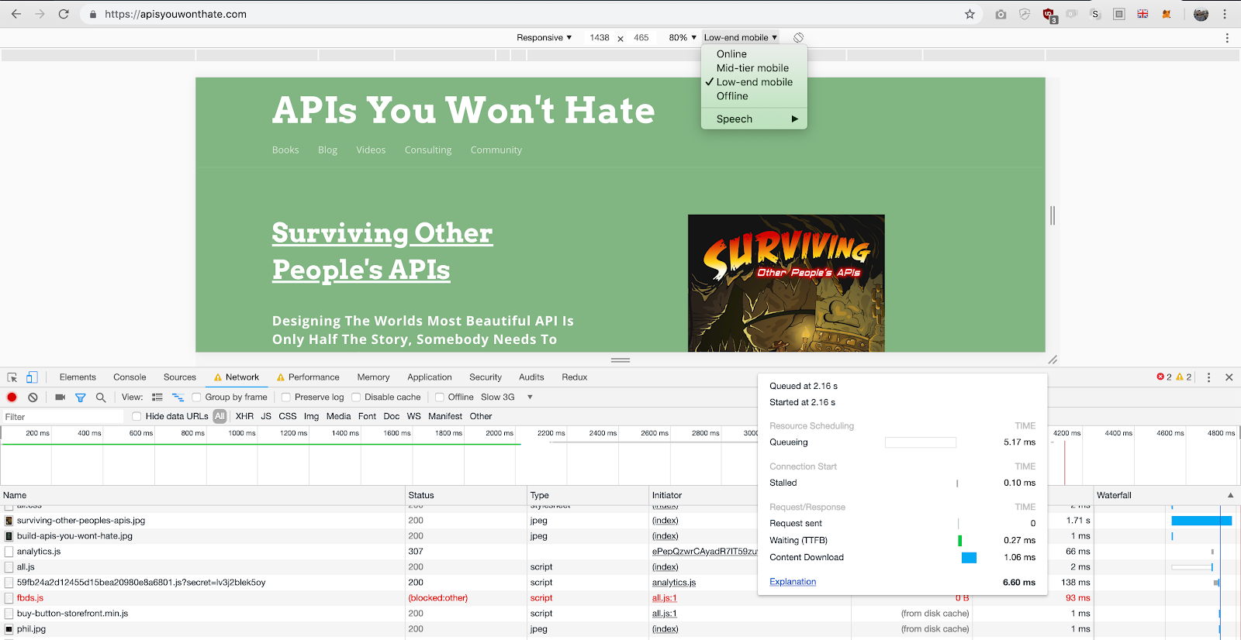
Chrome DevTools can simulate different bandwidth options on your site. It’s an eye-opening experience.

This, of course, begs the question: what can we do to make the page loading experience better for our users? A good place to start is to think about experiences you’ve had with sites and apps that behave badly when it comes to loading data on a page.

You’ve undoubtedly come across a website whose content loads in unpredictable chunks - with content appearing and unfolding haphazardly on the page right in front of your eyes, pushing content you were trying to read down without warning. This is a step better than the “Web 1.0” days where you’d need to wait for everything to load before displaying any content, but only because there’s a chance you may be able to get to what you’re looking for slightly more quickly. It’s tricky business trying to guess what’s going on in an app while content is popping into existence left and right, changing the layout of the page as it arrives back from its journey through the API.

Think of it this way: you know that one website you use, where you go to click on the link to [the thing you want to do], but just as you go to click on it, something on the page loads just above where you’re about to click, causing the page to reflow so that you click the [Sign Out] button instead of that one simple thing you wanted to do?

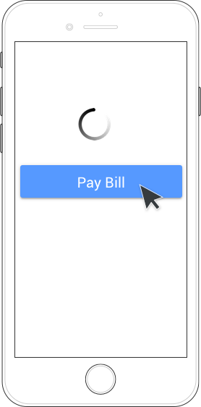 | 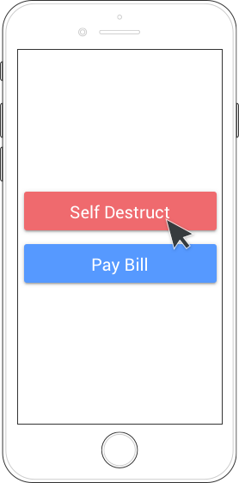
Yeah, holy shit, right? Me too. Our goal here is to avoid this.

There’s a few great, proven patterns we can use to avoid that kind of rage-inducing experience. While you're waiting on data to come back from an API, render content placeholders on screen.


Facebook does a great job of this - while timeline content is loading, animated data placeholders are displayed in a way that makes the application feel alive.

Progressive data loading
Users are able to anticipate where new content will load on screen. Gradients which represent usernames and post content are subtly animated, which prevents users from thinking something has gone wrong. If you're viewing facebook from a device with a decent connection to the web, this can all happen incredibly quickly, but the end result is an interface which feels like it is responding to your request for more content (by scrolling down the page).
If a particular request is taking a long time to complete, inform you users that you're still loading a response. If your user closes your app or page due to slow loading, you both lose. This can be as simple as changing a loading status from "Loading..." to "Still waiting..." after a few moments.

 | 
Netflix loads each show individually, maintaining their position in the grid on-screen while others load. You’ll never accidentally tap the wrong show!

 | 
The BBC’s website loads images last, but holds their position in the layout until images are loaded.

Lucky for you, some of these effects are fairly easy to accomplish on your own. What’s even better is that with a quick search of your favorite open-source repositories, you may find community-supported libraries, packages, and plugins that support this sort of behavior. Some examples include react-placeholder (React), and ngx-content-loader (Angular).

